**Google Drive API Usage / Test Cases**

**Introduction :**

This API helps in Upload,Download and View Files present in Google Drive.The Client Credentials are Stored in resources so that it will use my Google Account Credentials to Performs the Operations.The technologies used are Java,Maven,Jersey and Servlets.

This Assignment have providing me a good learning Scope.Thanks for the opportunity.

**Regards,**

**Harsha Vardhan Naidu Ganagavarapu**

* **Get Files and Folders Present in a Folder :**

1. **REST URL :** http://{WarFileName}:{PORT_NO}/GoogleDriveAPIAssesment/rest/gdapi/list
2. **Call Type :** POST
3. **Content Type :** application/json
4. **Required Parameters :** folderName
5. **Example :**

**{**

**"folderName" : "API Test"**

**}**

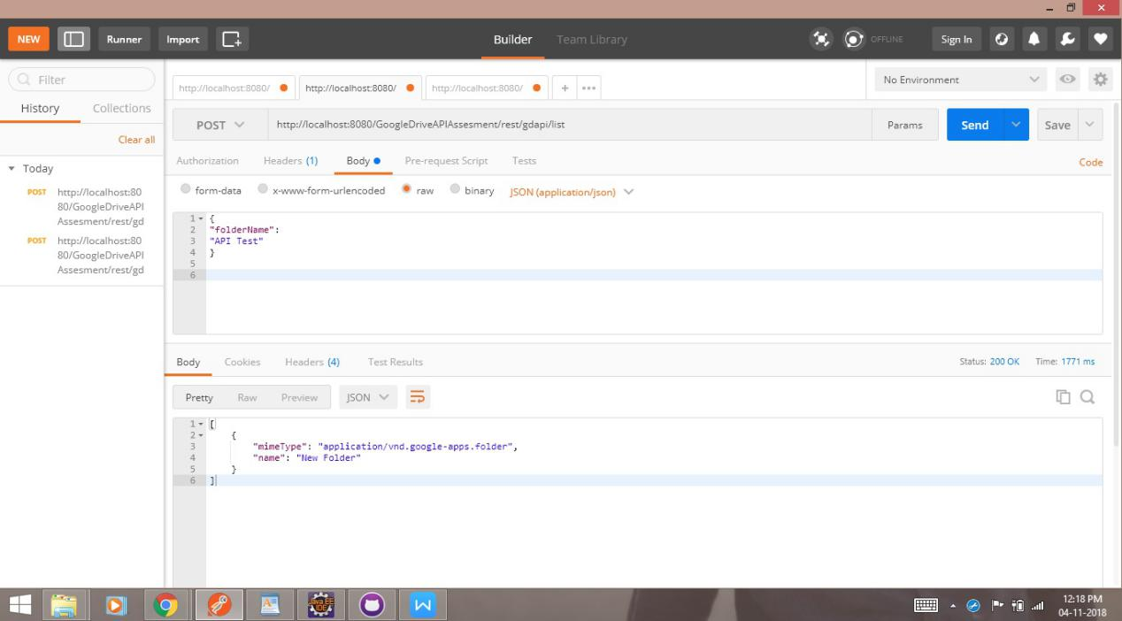

* **Upload a file to a folder :**

1. **Rest URL :** http://{WarFileName}:{PORT_NO}/GoogleDriveAPIAssesment/rest/gdapi/upload
2. **Call Type :** POST
3. **Content Type :** application/form-data
4. **Required Parameters :**

file and folderName

**Note : Try to Upload only .txt files as code handles only Text files.**

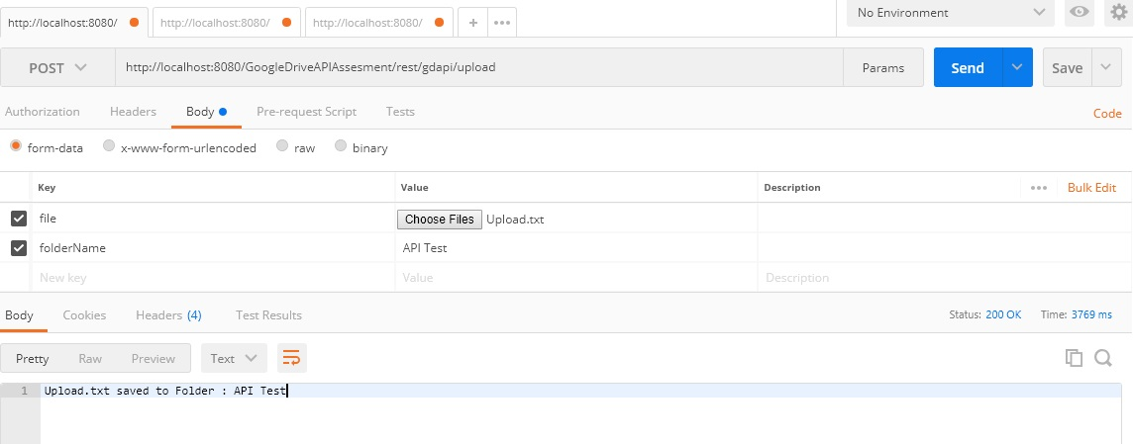

* **Download a file from a folder :**

1. **Rest URL :** http://{WarFileName}:{PORT_NO}/GoogleDriveAPIAssesment/rest/gdapi/download
2. **Call Type :** POST
3. **Content Type :** application/form-data
4. **Required Parameters :**

file and folderName

1. **Example :**

{

"folderName":"API Test",

"fileName":"Upload.txt"

}

1. **Click Send and Download Button**

